Pro

**Template**

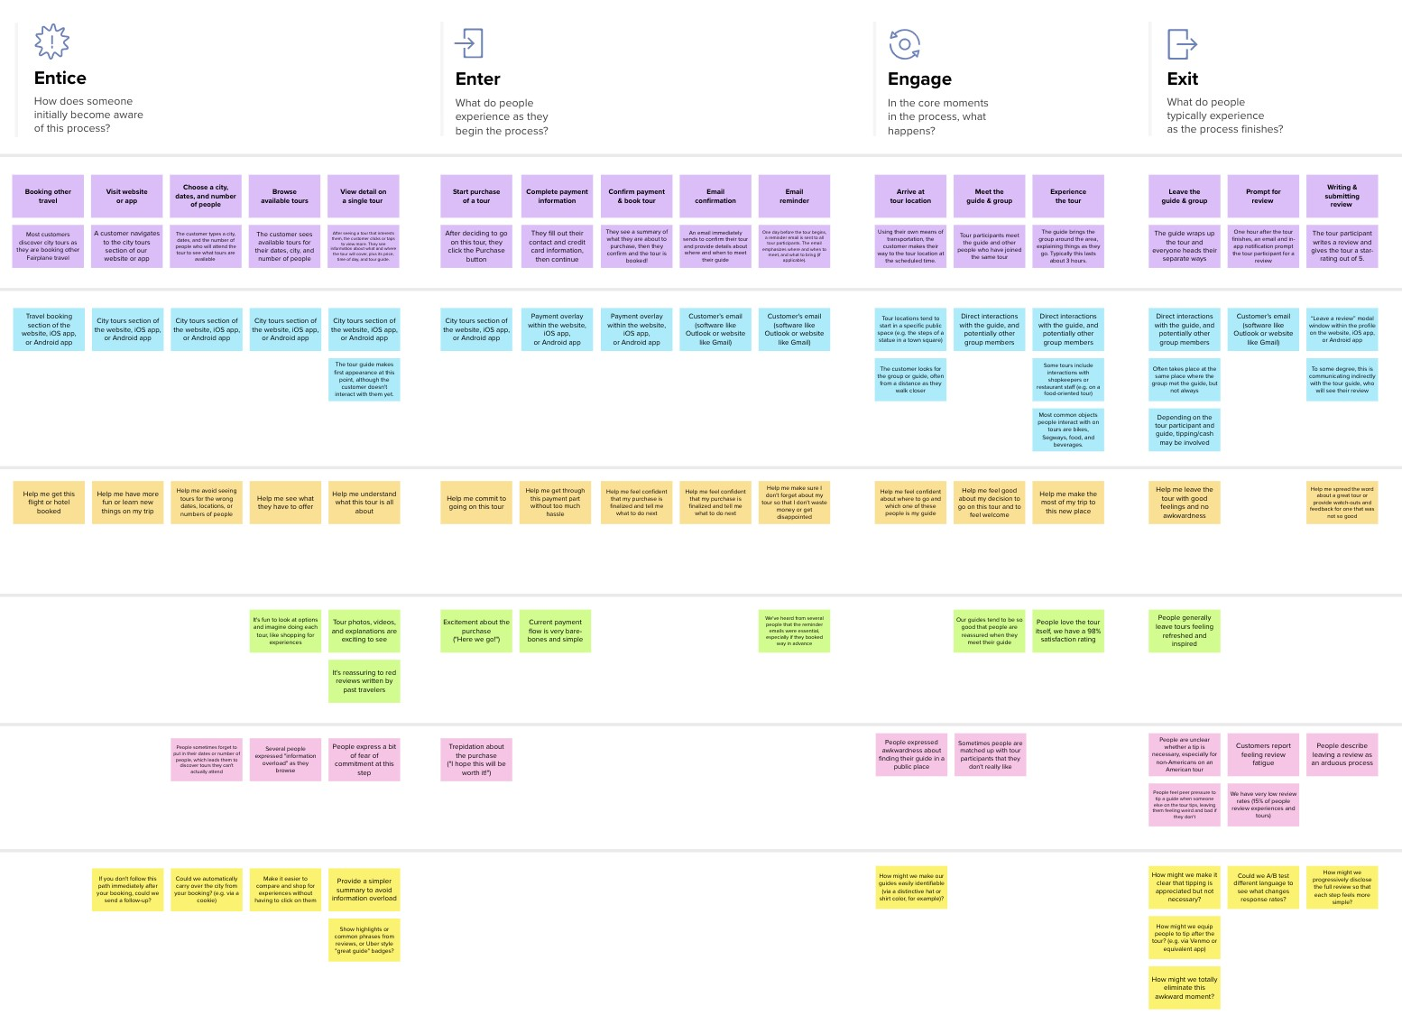

**TIP**

As you add steps to the experience, move each these “Five Es” the left or right depending on the scenario you are documenting.

**Document an existing experience**

Narrow your focus to a specific scenario or process within an existing product or service. In the **Steps** row, document the step-by-step process someone typically experiences, then add detail to each of the other rows.

Customer  experience

|  |  |  |  |  |  |  |  |
| --- | --- | --- | --- | --- | --- | --- | --- |
|  | | | **Entice**  How does someone initially become aware of this process? | **Enter**  What do people experience as they begin the process? | **Engage**  In the core moments in the process, what happens? | **Exit**  What do people typically experience  as the process finishes? | **Extend**  What happens after the experience is over? |
|  | **SCENARIO**  **Browsing, booking, attending, and rating a local city tour** |  |
| **Steps**  What does the person (or group) typically experience? | | | **Quick Quality of**  **information information**  **retrieval**  **Updated information** | **News Tracking Optimized user**  **System interface** | **Segregate all Information is**  **types of updated every**  **information second and**  **displayed**  **Prioritize the information by updated one** | **Summary of the Information can**  **information is be saved and can**  **shown be read latter.** | 0  **Notifies you about the updated information in your phone** |
| **Interactions**  What interactions do they have at each step along the way?  **People:** Who do they see or talk to?  **Places:** Where are they?  **Things:** What digital touchpoints or physical objects would they use? | | | **Only registered or**  **User able to register authorized user can**  **by their own be able to login into the application**  **Application** | **Authorized Display the user**  **access of user choice of category**  **displaying the news by the category of selection** | **Questions can be raised by the particular user in**  **Live chat bot the chat box under**  **every news summary**  **All news cover up all the details of the particular incident** | **Answers are shared**  **for the particular Search engine**  **question asked in the optimization**  **chat box by different**  **users.** | **Notify if comments**  **Social media are reversed or**  **channels changed by other users** |
| **Goals & motivations**  At each step, what is a person’s primary goal or motivation? (“Help me...” or “Help me avoid...”) | | | **To acheive more To seek different**  **information in a news with different**  **limited number of perception**  **time** | **To satisfy the user To swipe various**  **with number of news to gain**  **options to choose knowledge across** | **To reach the end of To receive instant**  **the news in limited messages from**  **number of updates the chat box** | **Wait for the To Spend time for**  **proper update to delivering the news**  **deliver to friends , family**  **and relations** | **Time saving More**  **Efficient** |
| **Positive moments**  What steps does a typical person find enjoyable, productive, fun, motivating, delightful, or exciting? | | | **Information rate Notification of news** | **Cost savings Greater insights** | **Increased user Avoiding Excess**  **rate information** | **Schedule Automated**  **maintenance Reordering** | **Advanced Quick response of**  **information retrieval messages** |
| **Negative moments**  What steps does a typical person find frustrating, confusing, angering, costly, or time-consuming? | | | **News delay Related search results** | **Lagging of Many searches**  **application due to found for a**  **adds in the internet particular news** | **Changing news**  **often may hang up Untold news breaking up the whole when another news is application been updated** | **Poor news clarity Random comments**  **due to disturbance which leads to a debate**  **of internet for a particular news** | **Delaying of Political news such as election might want to**  **notifications due to wait for a long period**  **bad management of of time to get the**  **internet results** |
| **Areas of opportunity**  How might we make each step better? What ideas do we have? What have others suggested? | | | **Centralized tracking** | **Selective database** | **Efficient retrieval of information** | **Optimized search engine** | **Unguided performance** |

journey map

Use this framework to better understand customer needs, motivations, and obstacles by illustrating a key scenario or process from start to finish.



When possible, use this map to document and summarize interviews and observations with real people rather than relying on your hunches or assumptions.



Created in partnership with



[**Share template feedback**](https://muralco.typeform.com/to/CiqaHVat?typeform-source=app.mural.co)



**Need some inspiration?**

See a finished version of this template to kickstart your work.

[**Open example**](https://app.mural.co/template/f59f644b-b4b4-47b5-9ed6-3a8c71ceb612/896b31fe-5597-40ef-9b06-3811a1a45ace)